What Is a Motherboard? (In-Depth, Practical Explanation)
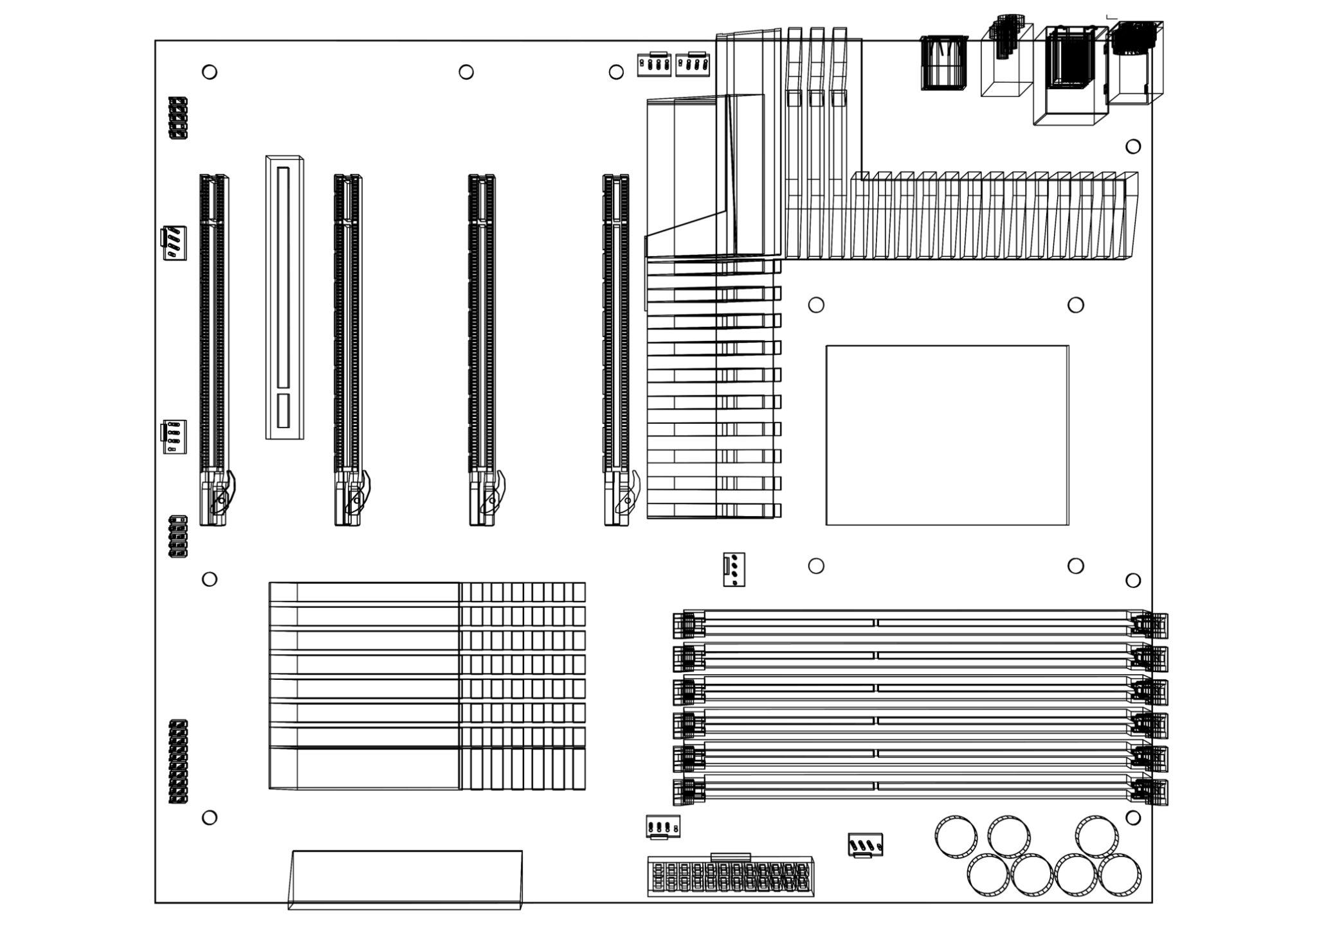
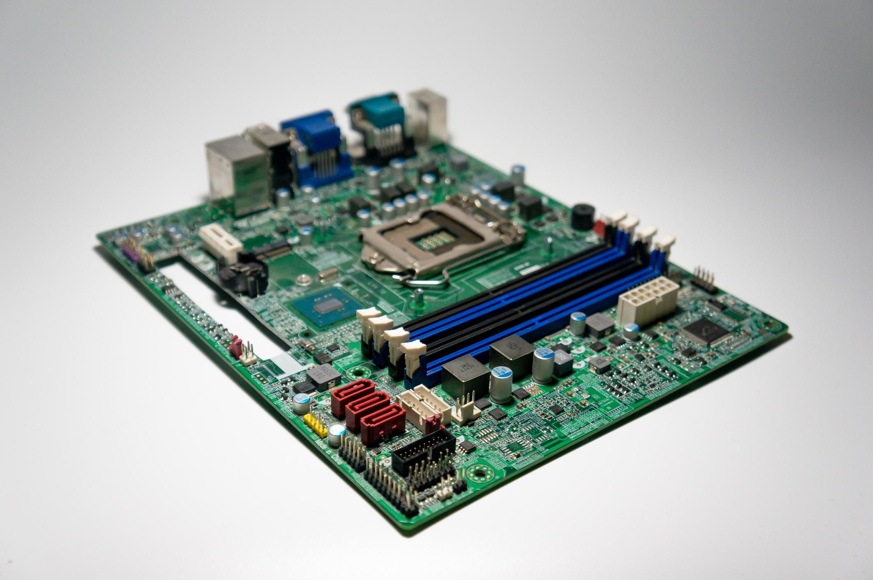
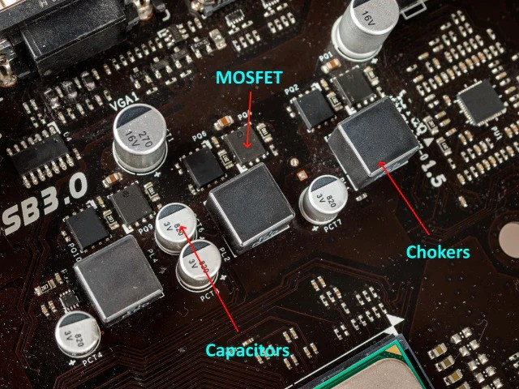
🔌 Main circuit board
The motherboard is the foundation of the computer. Every major component plugs into it.
🔗 Connects all components
It physically and electrically connects:
- CPU
- RAM
- GPU
- Storage (SSD/HDD)
- Power supply
- USB, LAN, audio, display ports
⚡ Controls communication & power delivery
- Routes data signals between components
- Distributes power safely and stably
- Sets operating limits (RAM speed, PCIe version, CPU boost behavior)
🔄 Decides upgrade path
Your motherboard decides:
- Which CPUs you can install
- Max RAM speed & capacity
- PCIe generation (GPU / SSD speed)
- Overclocking support
Think of the motherboard as the city map: even a fast car (CPU) can’t perform if the roads (power, lanes, cooling) are poor.

🧩 CPU & Socket Dependency
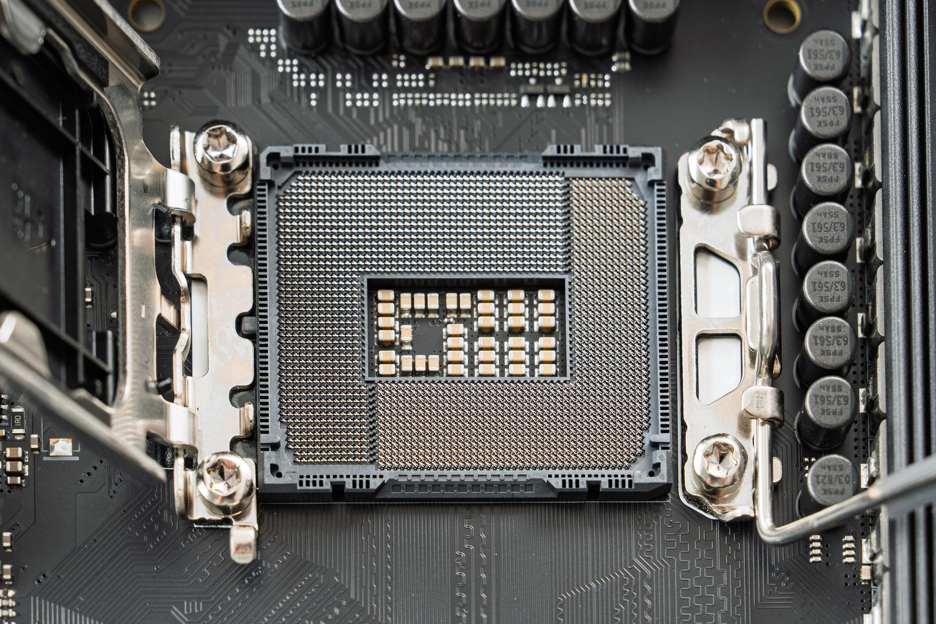
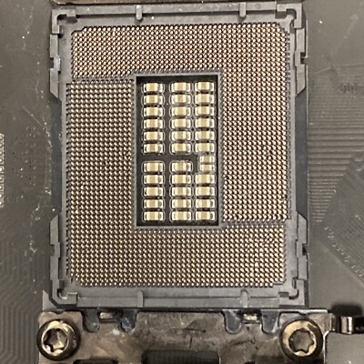
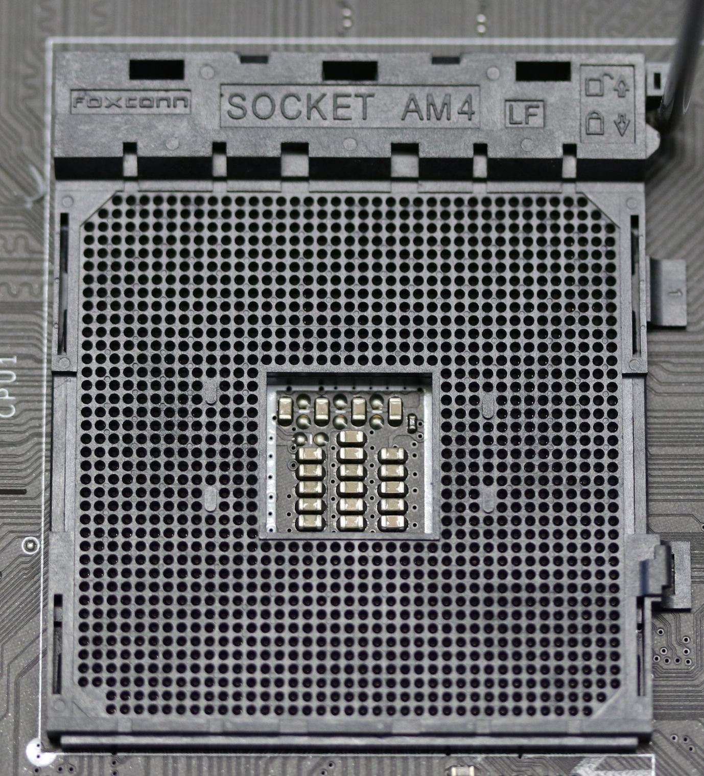
🔌 Socket = physical CPU connection
The socket is the exact shape and pin layout where the CPU fits.
CPU and motherboard socket must match.

🔵 Intel
- Uses LGA sockets (pins on motherboard)
- Examples:
  - LGA1200 → 10th/11th Gen
  - LGA1700 → 12th/13th/14th Gen
Meaning: You can’t put a 12th Gen Intel CPU into an older LGA1200 board.

🔴 AMD
- Uses AM sockets (pins on CPU)
- Examples:
  - AM4 → Ryzen 1000–5000
  - AM5 → Ryzen 7000+
Meaning: AM4 had long support → better upgrade flexibility.

🧠 Motherboard Chipsets Explained (Very Important)


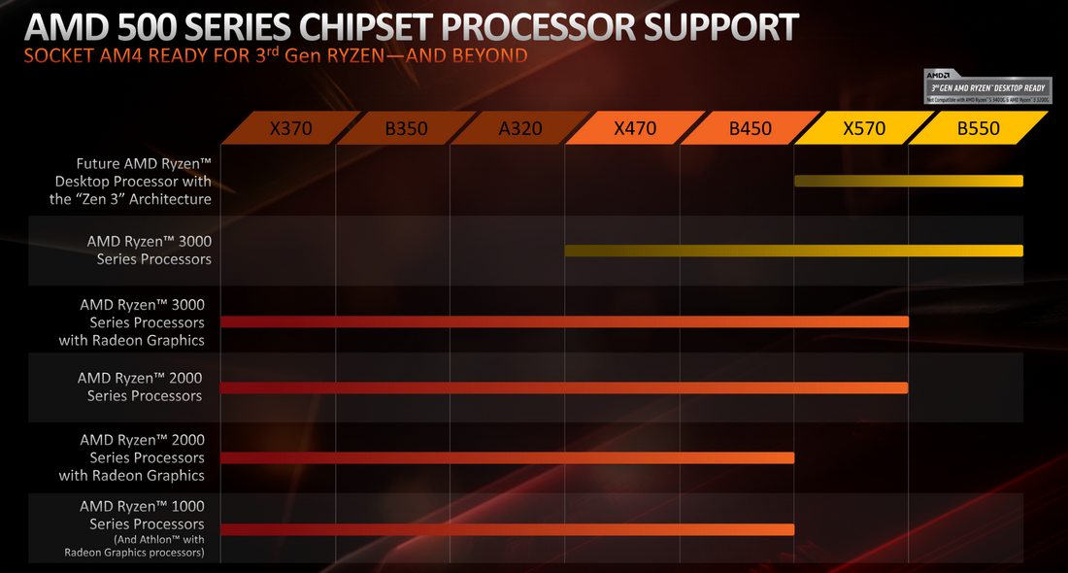
A chipset is the controller that defines features and limits of the motherboard.

🔵 Intel Chipsets
H-Series → Basic
- No overclocking
- Limited RAM speed
- Fewer USB & PCIe lanes
- Office / budget builds
B-Series → Balanced
- Better RAM support
- Good I/O
- No CPU overclocking
- Best for students & developers
Z-Series → Overclocking
- CPU + RAM overclocking
- Strong VRMs
- More PCIe lanes
- Enthusiast / gaming rigs

🔴 AMD Chipsets
A-Series → Entry
- Basic features
- Limited expansion
- Office / basic use
B-Series → Best Value
- RAM & CPU tuning
- Good VRMs
- Excellent for coding & multitasking
X-Series → High-End
- Maximum PCIe lanes
- Strongest power delivery
- Multi-GPU / heavy workloads

🤔 Why the SAME CPU Performs Differently on Different Motherboards

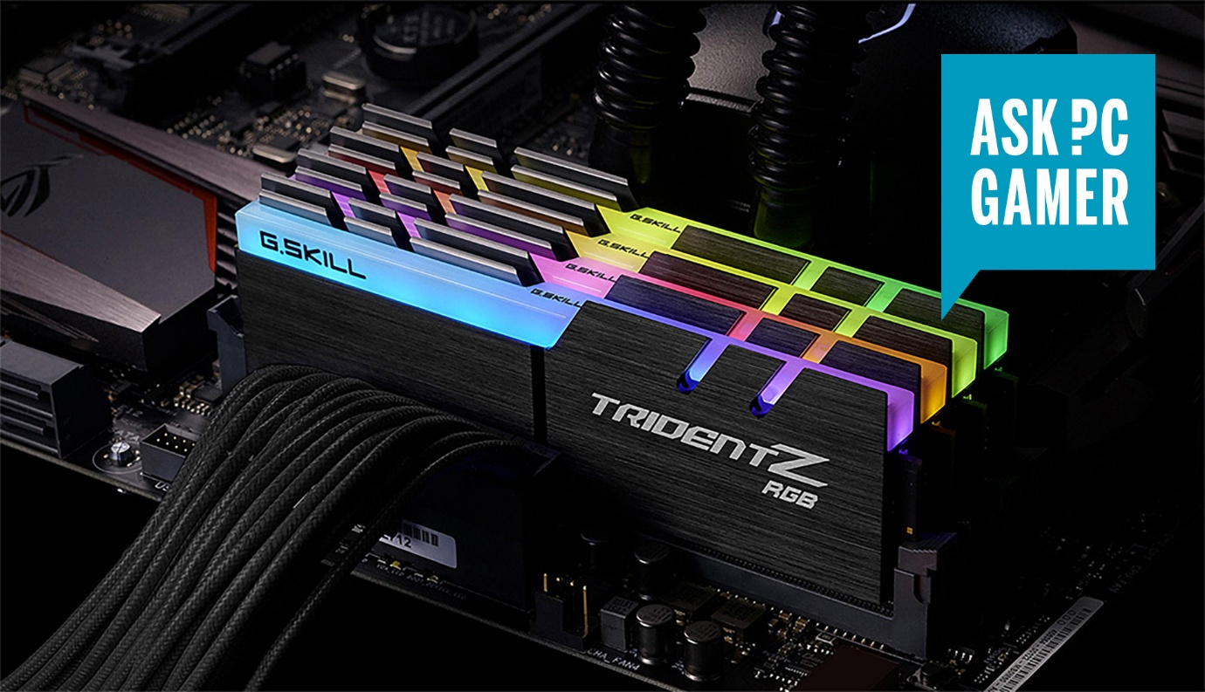
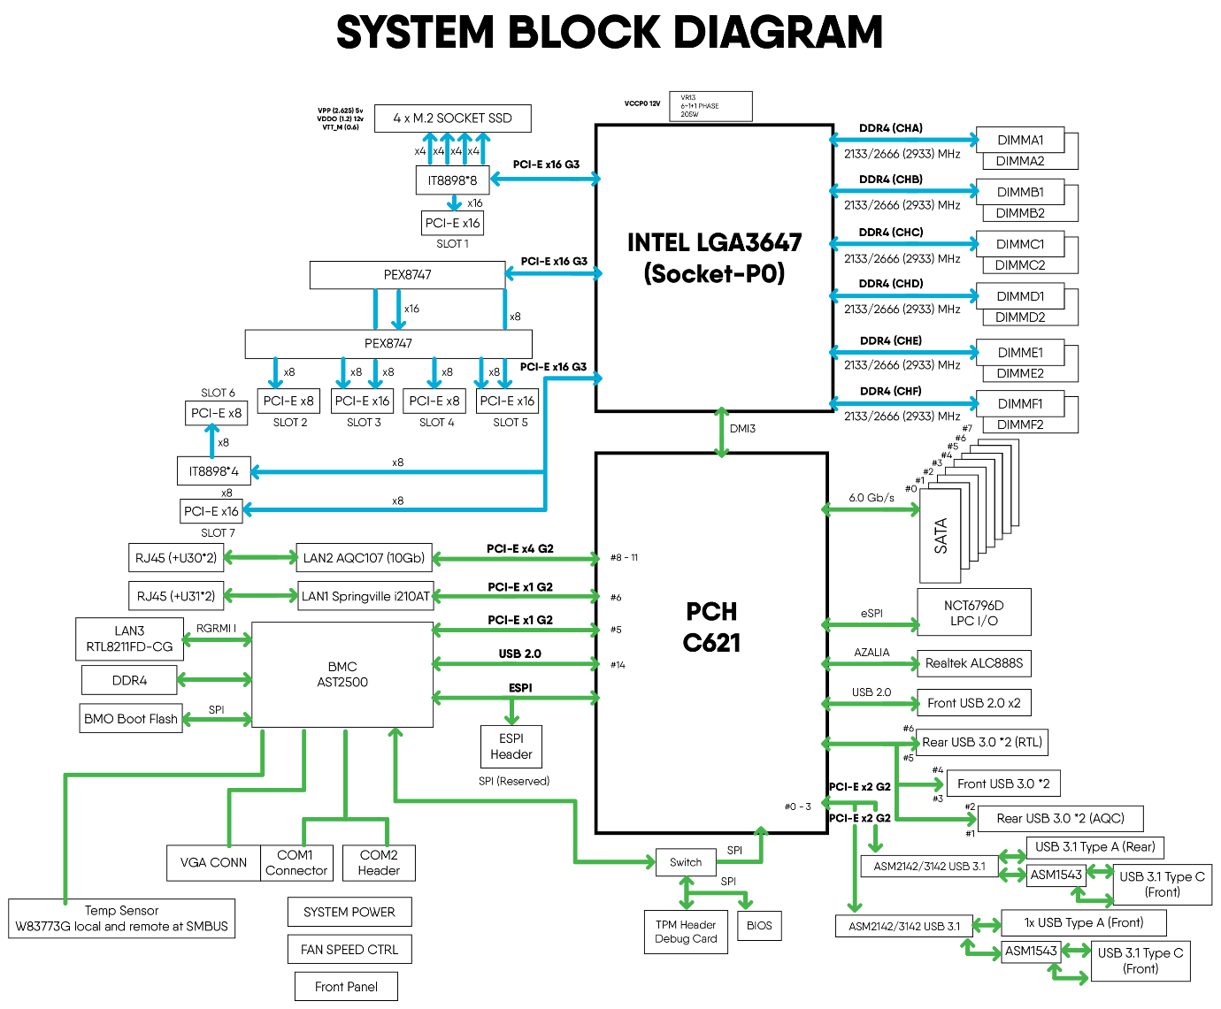
4
Even with the same CPU, performance can change due to:

1️⃣ 📊 RAM Speed Support
- CPU may support DDR4-3200
- Cheap board may limit to DDR4-2666
- Performance loss:
  - Slower apps
  - Lower FPS
  - Slower AI/data workloads
📌 RAM speed is controlled by the motherboard chipset + BIOS

2️⃣ ⚡ Power Delivery (VRMs)
What are VRMs?
Voltage Regulator Modules supply clean, stable power to the CPU.
- Weak VRMs → CPU throttles
- Strong VRMs → CPU boosts higher & longer
📌 Result:
- Same CPU
- Cheap board → lower sustained speed
- Good board → higher real-world performance

3️⃣ 🔌 PCIe Lanes
PCIe lanes decide:
- GPU bandwidth
- NVMe SSD speed
- Expansion cards
Board Type | PCIe Result
Entry | Limited lanes
Mid-range | Balanced
High-end | Maximum
📌 Example:
- PCIe 3.0 SSD on cheap board
- PCIe 4.0 SSD on good board → 2× speed

4️⃣ ❄️ Cooling Support
Motherboards control:
- Fan headers
- Pump support
- Thermal sensors
Poor board:
- Fewer fan headers
- Less thermal control
- CPU throttles earlier
Good board:
- Multiple fans
- Stable temps
- Sustained performance

🧪 Real-World Example
Same CPU: Ryzen 5 5600X
Motherboard | Result
A-Series | Lower RAM speed, throttling
B-Series | Full performance
X-Series | Best boost, cooler, faster

🧠 Simple One-Line Truth
CPU gives potential. Motherboard decides how much of that potential you actually get.

